

THE AIR MARSHALLS

THE AIR MARSHALLS

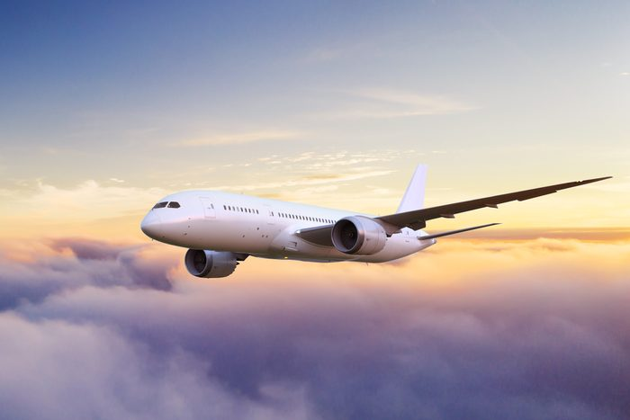

Airline Flight Delays USA 2015

Cristina Iovu

Mwamba Mwape

Khuseyma Egaal

Daniela Shae-Bebeyi

Kirran Kayani

Chadi Ghosn

**Introduction**

The following report undertakes analysis on flights in the US in 2015, in order to understand the major causes of flight delays and cancellations.

**How does the overall flight volume vary by month in 2015?**

From the graph, it can be concluded that flight volume increases in the summer months. July saw the highest number of flights, at 520,718. There was a sharp decline in flights in September to 464,946, from 520,718 in July. This can be expected as this is when the school term begins in the US.

There is also an uptick seen in December, as this is a popular time for travel due to Christmas and New Year’s holidays.

It should be noted that the sharp decline in flights seen in February has been identified as an extreme cold weather event in the US at this time, which would not normally occur.

**What percentage of flights experienced a departure delay in 2015? Among those flights, what was the average delay time, in minutes?**

In 2015, 36.5% of flights in the US experienced a departure delay, of which the average delay time was 33 minutes.

It can be seen from the data that the proportion of departure delays that an airline incurs does not relate to the average length of the delay. The airline with the highest proportion of departure delays was United Air Lines Inc. (UA) with 49.8% of its flights experiencing a delay, and an average delay time of 33 minutes. However, Frontier Airlines Inc. (F9) saw 38.4% of its flights experience departure delays, and had the longest delays, with an average delay time of 45 minutes.

The graph above shows that, despite airlines having longer average departure delays, they experience shorter average arrival delays. This could imply that flights increase their speed, in order to reduce airtime, which results in lower arrival delay times.

**How does the delayed flights % vary throughout the year (monthly)?**

From the chart below, we can see that December and February have the highest proportion of flights that saw a delay. This is expected due to the weather conditions in the winter months. September through November have the least proportion of delayed flights, as the weather conditions are most favorable during this period.

Further research identified that the spike in delays seen in June and July were due rain and floods seen in parts of the US.

**What are the top 5 busiest origin airports in 2015? And what are the top 5 origin airports with the highest departure and arrival delays?**

The top 5 busiest airports are as follows:

1. ATL (Hartsfield-Jackson Atlanta International Airport)
2. ORD (Chicago O'Hare International Airport)
3. DFW (Dallas/Fort Worth International Airport)
4. DEN (Denver International Airport)
5. LAX (Los Angeles International Airport)

The top 2 busiest airports hold 50% of the flights leaving the top 5 busiest airports.

The top 5 busiest airports also have the highest amount of departure delays. 4 of the top 5 airports also have the highest amount of arrival delays, with ATL being excluded and the addition of IAH (George Bush Intercontinental Airport).

**How many flights were cancelled every month for the top 5 busiest origin airports?**

Of the top 5 busiest airports, Chicago O'Hare International Airport (ORD) saw the highest number of cancellations, at 8,548, with the majority being in January and February. This was followed by Dallas/Fort Worth International Airport (DFW) with 6,254 cancellations. However, the graph below shows this airport saw the highest number of cancellations within a month, at 2,000 cancellations in February.

The data implies that, generally, the busier the airport the higher the number of cancellations. However, the busiest airport, Hartsfield-Jackson Atlanta International Airport (ATL), saw a significantly lower number of cancellations when compared to the remaining top 5 busiest airports.

**How many flights were cancelled in 2015? What % of cancellations were due to weather? What % were due to the Airline/Carrier fault?**

89,884 flights were cancelled in 2015. Of these, the majority (54.4%) were due to the weather, and 28.1% were due to an airline/carrier fault.

The graph below shows February saw the highest number of cancellations; 22.8% of flights were cancelled within this month. However, further research identified that the US experienced an extreme cold weather event at this time, which could have caused this spike in cancellations.

Separate to this, as expected, there are a higher number of cancellations during the winter months, largely due to the weather, with a consistent increase from October to December.

**Which airlines seem to be most and least reliable, in terms of on-time departure in 2015?**

Based on the below data frame, “WN” Southwest Airlines Co. had the highest number of on-time departure which qualifies it to be the most reliable airline in the USA. In 2nd and 3rd place we have “DL” Delta Air Lines Inc. and “AA” American Airlines Inc. respectively.

On the other hand, “HA” Hawaiian Airlines Inc. is the least reliable airline with the lowest number of on-time departure 3,132 in 2015. Then we have “F9” Frontier Airlines Inc. with 3,253 on-time departure and finally “VX” Virgin America, third least reliable airline with 3,883 on-time departures.

**Which airlines on average depart before the set schedule in 2015?**

Fig. 1

Based on the data frames created figure 1 shows the average early departure flights grouped by each airline. On the other hand, we can clearly see in figure 2 that “AS” Alaska Airlines Inc., “F9” Frontier Airlines Inc. and “NK” Spirit Air Lines has the highest average of early departures, which means that on average, these 3 airlines were the top airlines at being able to account for all their passengers during the flight and leave the runway earlier than the scheduled time.

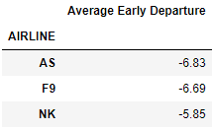

Fig. 2

**How does the distance of a trip have an influence (if any) on the arrival/departure delay of a flight?**

The graphs below show a slight negative correlation between the distance of a trip and the delay a flight faces. As the majority of flights within the dataset have relatively short delay times, the correlation coefficients are close to 0, implying little to no correlation.

**Hypothesis Testing**

Null hypothesis: There is no relationship between the total number of flights per airline and the total departure delay time.

Alternative hypothesis: There is a directly proportional relationship between the total number of flights per airline and the total departure delay time.

The p-value for this test was 0.0005, which means we can reject the null hypothesis as the relationship between the number of flights an airline carries out the total time spend delayed is not mutually exclusive. This finding is further demonstrated by the graph below which shows that there is a strong positive correlation between the total flights of an airline and the total time delayed.

**Conclusions**

The key conclusions to take away are:

* The majority of delays and cancellations are due to the weather and so they are at their highest during the winter months when there are adverse weather conditions.
* Generally, the busier the airport, the more delays and cancellations there are. However, ATL is the busiest airport and has lower rates of delays/cancellations when compared against the remaining top 5 busiest airports.
* There is a strong positive correlation between the number of flights an airline undertakes and the total time spent delayed.